**Coding Standards – Entities**

1. Using statements must be placed above namespace.

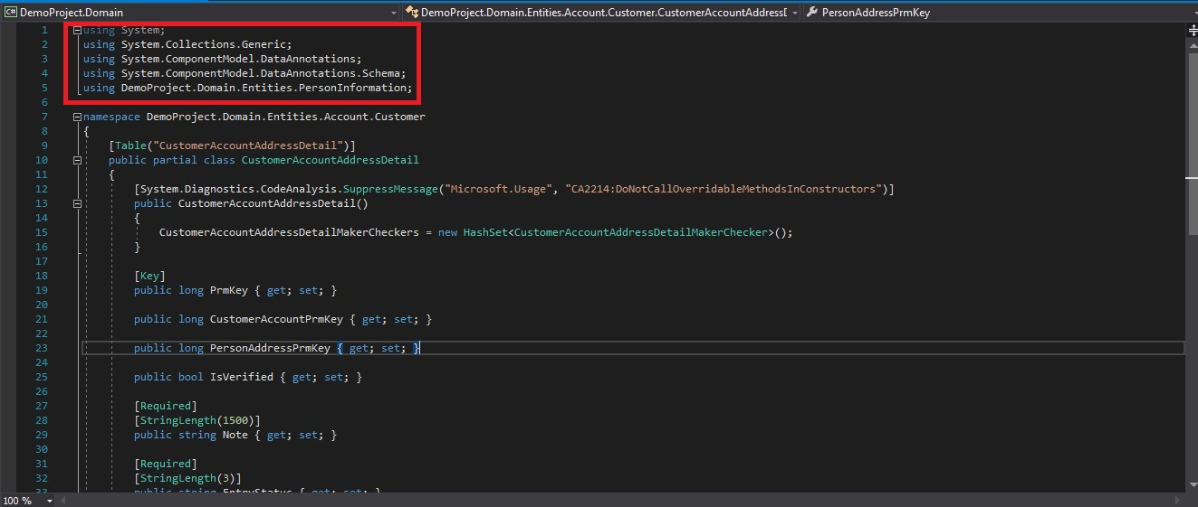

1. 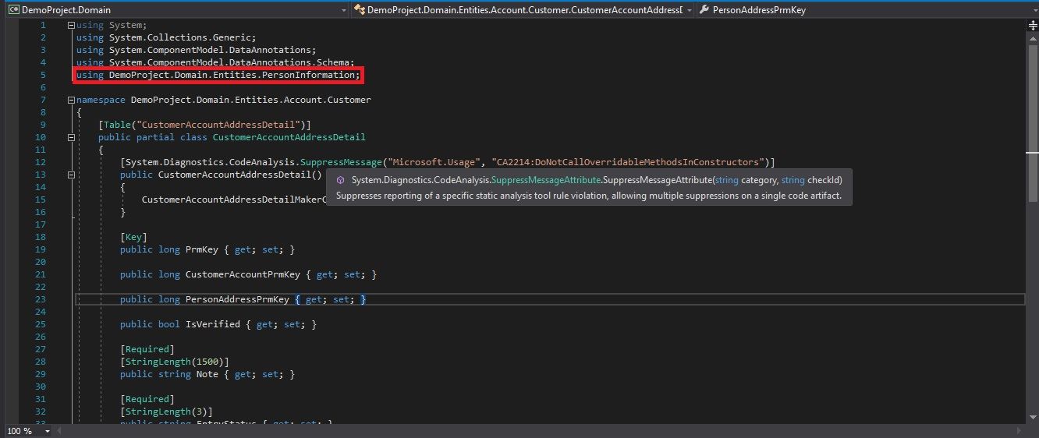User defined using statements must be declare below system’s using statements.
2. 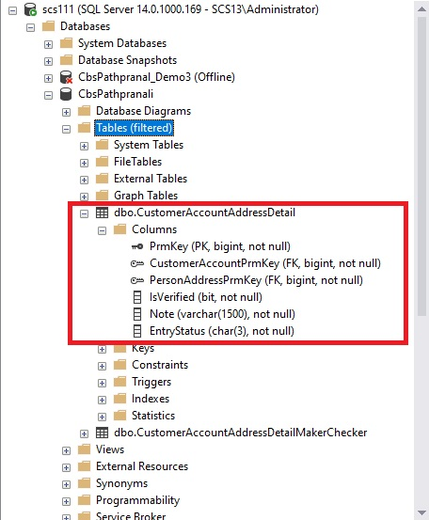Entities cannot be Hardcoded, it must be copied form database table and must be mapped with database table fields.

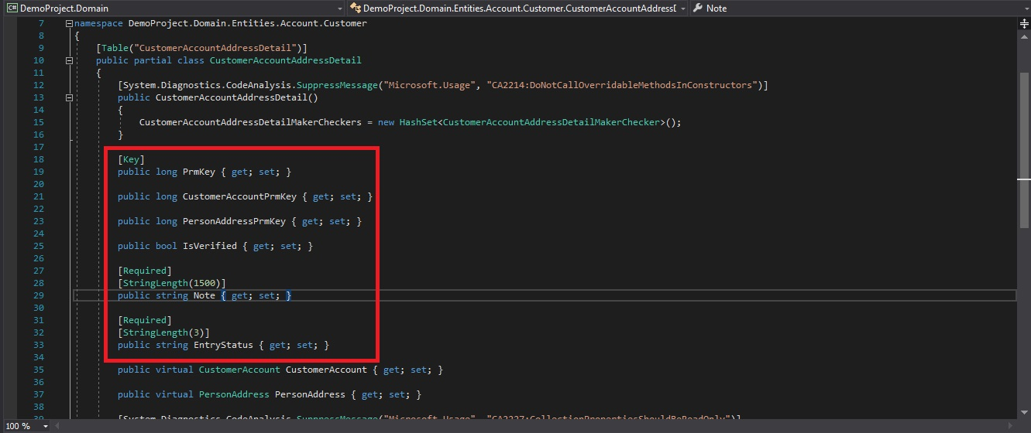

1. 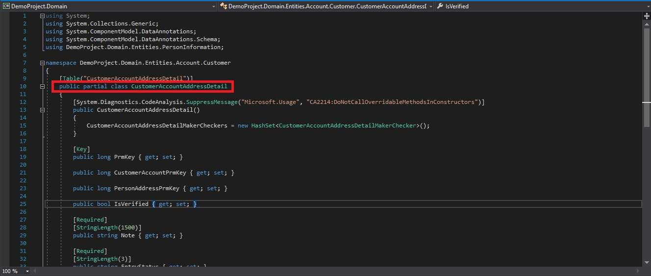Entity class must be a partial class.
2. Folder structure should be well organized regarding each entities.

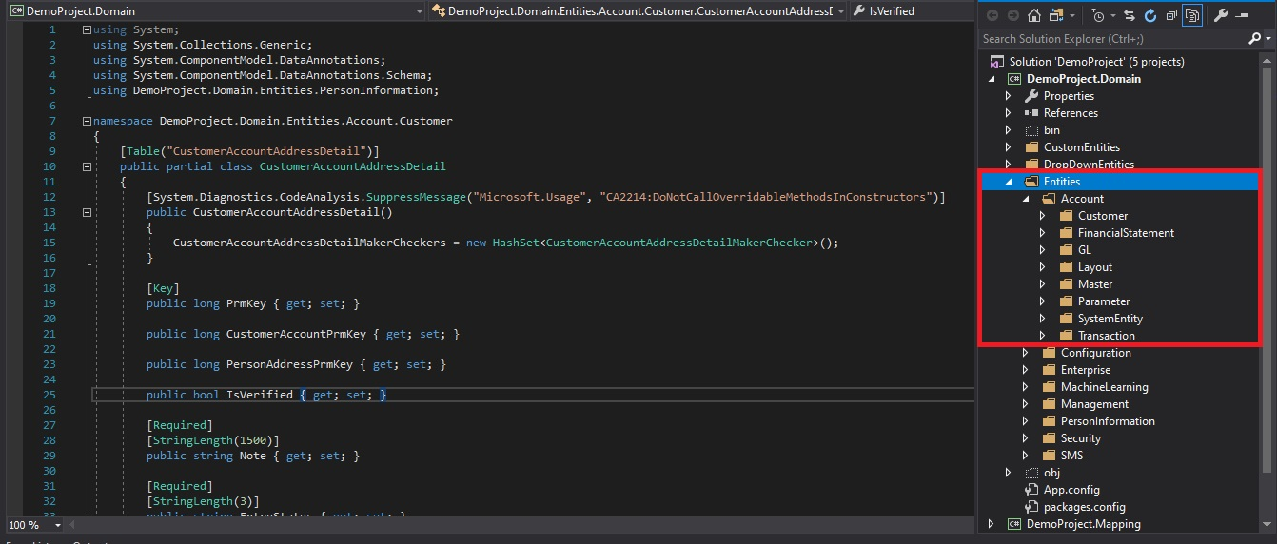

1. Must declare relations if exists between entities.

